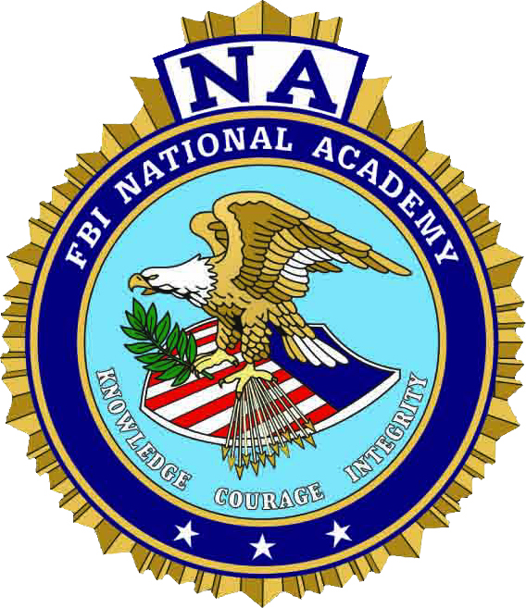
FBI NATIONAL ACADEMY
WISCONSIN CHAPTER
PRESIDENT’S SCHOLARSHIP
2024-2025 ACADEMIC YEAR

The Wisconsin Chapter of the FBI National Academy Associates is pleased to offer its annual undergraduate scholarships. The Chapter utilizes a competitive process to select the recipients. One $1000 scholarship will be awarded and other $500.00 scholarship(s) may be awarded by the Executive Board.

The intent of this program is to:
- Support and encourage youth development through continuing education at an accredited College or University
- Promote community involvement
- Encourage demonstrated leadership
- Encourage active membership in the Wisconsin Chapter of the FBI National Academy Associates
- Serve as a means of giving back to our members

Applicants for the President’s Scholarship must demonstrate and will be independently evaluated, based on academic achievement (25%), National Academy Association Affiliation of Sponsor (25%), community involvement (10%), extra-curricular activities (10%), and an essay (30%).

To be eligible the applicant must:
- Have a member sponsor, but they DO NOT need to be a relative to apply. However, preference points shall be awarded to applicants who are the child, stepchild, grandchild, niece, or nephew of an active member or other (NA Coordinator, Counselor) in good standing of the Wisconsin Chapter of the FBI National Academy Associates.
- Be enrolled in an undergraduate degree program at an accredited institution of higher learning.
- Complete the application form in its entirety and submit it and all required attachments electronically by the submission deadline.
Completed applications and academic transcripts must be submitted electronically.

The Scholarship selection committee will also give consideration to, and in the following order:

- High School Graduates applying for the first time for this scholarship.
- Prior applicants who did not receive a prior scholarship from the Chapter.
- Prior Chapter scholarship recipients.

All scholarship funds awarded will be sent directly to the educational institution upon proof of registration, to be deposited in the recipient’s school or college account. No direct payments will be made to recipients. Applicants must have been accepted to an accredited college or university and must be currently enrolled to be eligible for scholarship funds. When completing the application, please keep in mind that your materials will be closely reviewed and scored. Two areas that are evaluated and which need to be specific are; (1) Community Involvement – groups you belong to, activities you participate in outside of school. These may be activities like church groups, 4H, choirs, community organizations, etc. (2) Extra-Curricular activities – Separately, detail your involvement in activities that are associated with your school, such as band, sports, debate teams, etc. (You may add additional pages as necessary). The committee will look most closely at the last two years, so please be specific as to when the Community Involvement or Extra-Curricular Activities occurred. Pertinent data outside the two- year window may be included for consideration, but please denote when these activities took place as well.

Instructions for Completing and Submitting the Application

Applicants must submit a completed application, along with the required supporting documentation electronically, via email no later than 4:00 p.m. on March 31, 2024.
All application packets must be received by this date.

Required Supporting Documentation

- Academic Transcripts: Applicants must submit their most recent official academic transcript. If your school or college uses something other than a 4.0 GPA scale, they must interpolate the data into a 4.0 scale. Normally a guidance counselor can assist with this. Home school students must also submit the required information on GPA.

- National Academy Associate Affiliation of Sponsor: Applicants must submit a letter from their National Academy Sponsor that outlines the sponsor’s involvement with the Wisconsin Chapter. Such topics as paid years in the Chapter, volunteer work for the Chapter, attendance at Chapter functions, service as board and committee members, and any other pertinent information that the selection committee should be aware of.

- Essay: Applicant must submit a typed essay, not to exceed 1000 words, 12 font, double spaced, in response to the following:
Based upon your record, accomplishments and/or financial need, please cite the reasons the Wisconsin Chapter of the FBI National Academy Associates should award you a scholarship. Please be specific and concise, noting personal achievements and other facts that support the criteria for the scholarship.

If you have any questions, please contact the Scholarship Coordinator:

Ryan Shogren at: rshogren@northcentralhidta.org or 414-559-7889

YOUR APPLICATION MUST BE RECEIVED ON or BEFORE 4:00 p.m. on MARCH 31, 2024

EMAIL COMPLETED APPLICATION PACKET TO: jmrosploch@fbi.gov

GOOD LUCK!
FBI NATIONAL ACADEMY
WISCONSIN CHAPTER
PRESIDENT’S SCHOLARSHIP
APPLICATION
2024 - 2025 ACADEMIC YEAR

SCHOLARSHIP ELIGIBILITY

Name(s) of the sponsor who qualifies you for scholarship:
Sponsor’s Relationship to applicant:
Sponsor’s National Academy Session and Year:
Sponsor’s FBINAA Chapter:
Sponsor’s Current Agency/Department:

STUDENT APPLICANT INFORMATION

Last Name:
First name:
MI:
Date of Birth:
Social Security Number:

Mailing Address:
City:
State and Zip Code:

Home Phone Number:
Cell phone Number:
Email address:

Has the applicant been awarded the President’s Scholarship previously? If so, what year was the scholarship awarded?

Presently a high school senior?

Have you been accepted or are you enrolled as a full-time undergraduate student in a university or college?

Name of College or University:

Four-year ( ), Two-year ( ), No ( )

Date of anticipated graduation:

Have you ever served in the military Yes ( ), No ( )?

COMMUNITY INVOLVEMENT

Community involvement is unpaid volunteer work for the improvement and well-being of individuals, organizations or groups. Indicate your role and degree of involvement in community service.

EXTRA CURRICULAR ACTIVITIES

Identify other interests and activities that supplement your academic work and community service activities. These should be activities that are generally offered or are a part of your high school career. (List any honor society inductions in this section)

EMPLOYMENT HISTORY

Paid employment and planned income sources may demonstrate the applicant’s initiative, maturity and time management skills. Provide a list of your paid employment, including self-employment, and the types of positions held during the past three years.

ESSAY

Based upon your record, accomplishments and/or financial need, please cite the reasons the Wisconsin Chapter should award you a scholarship. Please be specific and concise, noting personal achievements and other facts that support the criteria for the scholarship.
(Attach essay on separate, additional page(s) as necessary).

CERTIFICATION

I certify that the information in this application is accurate and complete to the best of my knowledge. Falsification of any information will cause disqualification from the scholarship program. I authorize my high school or college authorities to release information concerning my character, reputation, scholastic ability or student activity to representatives of the Wisconsin Chapter of the FBI National Academy Associates as necessary for the scholarship program.

If selected as a recipient, I authorize release of my name to the Wisconsin Chapter of the FBI National Academy Associates to be used, where legal, for publicity purposes.

Applicant’s Signature: Date: _______________

*Parent or Guardian’s Signature: ___________________________ Date: _______________

*(Parent or Guardian signature required, if the applicant is under 18 years of age at time of
application submission).

APPLICATION COMPLETION CHECKLIST

- Completed application with signatures.

- Official high school or college transcript of grades.

- National Academy Associate Affiliation of Sponsor:

Applicants must submit a letter from their National Academy Sponsor that outlines the sponsor’s involvement with the Wisconsin Chapter. Such topics include paid years membership in the Chapter, volunteer work for the Chapter, attendance and participation at Chapter functions and events, and any other necessary information that the selection committee should be aware of.

- Completed essay included (attached).

YOUR APPLICATION MUST BE RECEIVED ON OR BEFORE 4:00 p.m. on March 31, 2024
EMAIL TO:

jmrosploch@fbi.gov

